

SCHOOL OF NATURAL AND SOCIAL SCIENCES

**Sociology and social psychology**

Scientific research project

"Managing internationalization in higher education"

Project work

by Amantai Aitolkyn,

Nyshanbek Tomiris, Kakharmanova Aruzhan

SITE, 2 year students

Supervisor: PhD Assoc. Prof. Tileubayeva M.S.

Almaty, 2023

**CONTENT**

**INTRODUCTION**

**I. THEORETICAL ASPECTS OF INTERNATIONALIZATION IN HIGHER EDUCATION**

1.1 Definition and concept of internationalization in higher education………………………

1.2 Motivations and drivers of internationalization…………………………………………...

1.3 Benefits and challenges of internationalization…………………………………………...

1.4 Role of internationalization in research excellence……………………………………….

**CONCLUSION OF THE 1ST CHAPTER**

**II. METHODOLOGY AND FORMULATION OF METHODOLOGICAL ASPECTS**

2.1 Research design and approach……………………………………………………………

2.2 Data collection and analysis methods…………………………………………………….

2.3 Analysis of the best practices and strategies for managing internationalization…………

**CONCLUSION OF THE 2ND CHAPTER**

**CONCLUSION**…………………………………………………………………………………...

**LITERATURE**…………………………………………………………………………………...

**Introduction**

Internationalization has become a buzzword in the higher education sector in recent years as universities around the world seek to attract students, faculty and research collaborations from different cultural backgrounds. Internationalization has been recognized as a means to enhance the quality of higher education, facilitate research excellence, and create opportunities for intercultural exchange. The globalization of the world economy and society has made it essential for universities to be globally connected and to operate on an international stage. Internationalization has become a key element of institutional strategy for many universities, and institutions are increasingly investing in policies and programs to foster internationalization.

This research paper aims to explore the strategies and challenges of managing internationalization in higher education. The paper will begin by defining the concept of internationalization in higher education and discussing its importance. The paper will then review the current literature on the topic, including the benefits and challenges of internationalization. The paper will also discuss the role of internationalization in research excellence and provide examples of best practices in managing internationalization. Finally, the paper will propose several strategies for managing internationalization, including the development of internationalization policies and programs, the cultivation of international partnerships, and the promotion of intercultural competence among students and faculty.

The purpose of this research is to investigate the best practices and strategies for managing internationalization in higher education. Specifically, the research aims to examine the policies and programs of selected universities and analyze their strengths and weaknesses. The research also aims to identify key factors for success in internationalization programs and provide recommendations for enhancing internationalization in higher education.

**I. Theoretical aspects of internationalization in higher education**

*1.1 Definition and concept of internationalization in higher education*

Internationalization has been defined in many ways, but the most commonly accepted definition is the one proposed by Jane Knight in 2004. According to Knight (2004), internationalization in higher education refers to the process of integrating an international, intercultural, or global dimension into the purpose, functions, and delivery of higher education. Internationalization can take many forms, including student and faculty exchange programs, joint research projects, international curriculum development, and international partnerships.

Internationalization in higher education refers to the process of integrating international and intercultural dimensions into the policies, programs, and activities of higher education institutions. It involves creating an environment that promotes cultural diversity, enhances academic excellence, and fosters global citizenship.

The concept of internationalization in higher education has evolved over the past few decades, driven by the increasing globalization of higher education and the growing demand for cross-cultural understanding and collaboration. It encompasses a wide range of activities, including study abroad programs, international student and faculty exchange, collaborative research projects, and partnerships with international institutions.

*1.2 Motivations and drivers of internationalization*

The motivations and drivers for internationalization in higher education are varied and complex, reflecting the changing needs and demands of students, employers, governments, and society at large. By embracing internationalization, institutions can enhance their reputation, provide students with valuable skills and experiences, and contribute to a more diverse and inclusive world.

1. Global competition: Higher education institutions are increasingly competing on a global stage for students, faculty, and funding. Internationalization can help institutions to enhance their reputation, attract high-quality students and faculty, and access new sources of funding.
2. Changing student demographics: The demographics of students in higher education are changing, with a growing number of international students seeking to study abroad. Internationalization can help institutions to meet the needs of these students and provide them with a supportive and inclusive learning environment.
3. Increasing demand for global skills: In today's globalized world, employers are looking for graduates with cross-cultural competency, language skills, and international experience. Internationalization can help institutions to prepare students for success in the global marketplace by providing them with the skills and experience they need to thrive.
4. Research collaboration: Internationalization can facilitate collaboration between institutions on research projects and provide access to new research opportunities and resources.
5. Government policies: Many governments around the world have policies aimed at promoting internationalization in higher education, such as funding for international student exchange programs or incentives for institutions to form international partnerships.
6. Social and cultural benefits: Internationalization can provide social and cultural benefits for students, faculty, and staff by exposing them to different cultures, perspectives, and ways of thinking. It can also promote mutual understanding and intercultural dialogue.

*1.3 Benefits and challenges of internationalization*

The benefits of internationalization in higher education are significant, but they must be balanced against the challenges and costs involved. By addressing these challenges and leveraging the benefits of internationalization, institutions can enhance their global engagement, promote cultural diversity and academic excellence, and prepare students for success in a rapidly changing world.

*Benefits of internationalization in higher education:*

* *Cultural diversity:* Internationalization in higher education promotes cultural diversity by exposing students, faculty, and staff to different cultures, languages, and perspectives. This can help to broaden their understanding of the world and foster intercultural dialogue.
* *Academic excellence:* Internationalization can enhance academic excellence by providing access to new research and teaching opportunities, collaborations with international partners, and exposure to different academic systems and approaches.
* *Global citizenship:* Internationalization can help to prepare students for success in a globalized world by promoting global citizenship and providing them with the skills and knowledge needed to navigate different cultural and linguistic environments.
* *Career opportunities:* Internationalization can increase career opportunities for students by providing them with international experience, language skills, and cross-cultural competencies that are highly valued by employers in today's global marketplace.
* *Institutional reputation:* Internationalization can enhance the reputation of higher education institutions by demonstrating their commitment to global engagement, diversity, and excellence.

*Challenges of internationalization in higher education:*

* *Cost:* Internationalization can be costly for institutions, particularly in terms of supporting international students, faculty exchange programs, and establishing international partnerships.
* *Language barriers:* Language barriers can pose a challenge to internationalization efforts, particularly for institutions that do not have the resources to provide language support or that operate in monolingual environments.
* *Cultural differences:* Cultural differences can pose a challenge to internationalization efforts, particularly in terms of communication, teaching styles, and expectations.
* *Regulatory and legal frameworks:* Different regulatory and legal frameworks in different countries can pose a challenge to internationalization efforts, particularly in terms of student mobility, accreditation, and intellectual property rights.
* *Institutional resistance:* Institutional resistance to change can pose a challenge to internationalization efforts, particularly if there is a lack of understanding or buy-in from key stakeholders.

*1.4 Role of internationalization in research excellence*

Internationalization plays a crucial role in enhancing research excellence in higher education. It offers numerous opportunities for research collaboration, knowledge exchange, and access to resources that are critical for conducting high-quality research. It can provide researchers with access to new research opportunities and resources, such as funding, data, and research facilities. By collaborating with international partners, researchers can gain access to new perspectives and expertise that can enhance the quality and impact of their research. Definitively internationalization can promote diversity and inclusivity in research by providing opportunities for researchers from underrepresented groups to participate in research collaborations and projects. This can lead to a more diverse and inclusive research community and promote equity in research.

***Conclusion of the 1st chapter***

So, internationalization in higher education refers to the process of integrating international, intercultural, and global dimensions into the teaching, research, and service functions of colleges and universities. The goal of internationalization is to prepare students for a globalized world and to promote cross-cultural understanding and cooperation. It is seen as a key driver of economic growth and innovation, as well as a means of promoting global peace and stability. It is also seen as a way of enriching the learning experience of students and faculty and enhancing the reputation and visibility of universities in the global marketplace. Internationalization encompasses a broad range of activities, including student and faculty exchange programs, international research collaborations, language and culture classes, study abroad programs, and international partnerships with other institutions.

**II. Methodology and formulation of methodological aspects**

*2.1 Research design and approach*

The formulation of methodological aspects of internationalization in higher education involves a structured approach that addresses key components of the internationalization process. The following are some methodological aspects that institutions can consider when developing and implementing an internationalization strategy:

*- Conduct a needs assessment:* Before developing an internationalization strategy, institutions should conduct a needs assessment to determine their current internationalization status, identify gaps and challenges, and assess stakeholder needs and expectations.

- *Develop a strategic plan:* A strategic plan is critical for guiding the internationalization process. It should include clear goals, objectives, and action plans that align with the institution's mission, vision, and values.

- *Establish leadership and governance:* Effective internationalization requires strong leadership and governance structures. Institutions should establish an internationalization committee or task force, appoint a dedicated internationalization officer, and ensure that internationalization is integrated into the institution's decision-making processes.

- *Develop partnerships and collaborations:* Partnerships and collaborations with international institutions and organizations can provide valuable opportunities for joint research, student and faculty exchanges, and knowledge sharing. Institutions should identify potential partners and establish formal agreements that outline the scope and goals of the collaboration.

*- Foster student mobility:* Student mobility is a key component of internationalization. Institutions should develop programs and initiatives that promote student mobility, including study abroad programs, exchange programs, and internships.

*- Develop cultural competency:* Effective internationalization requires cultural competency, which involves understanding and respecting different cultural values and practices. Institutions should provide cultural competency training for students, faculty, and staff to ensure that they have the skills and knowledge needed to engage in cross-cultural interactions.

*- Evaluate and assess internationalization efforts:* Institutions should establish a system for evaluating and assessing their internationalization efforts to determine whether they are meeting their goals and objectives. Evaluation and assessment should be ongoing and should involve stakeholders from across the institution.

So, the formulation of methodological aspects of internationalization in higher education involves a structured approach that addresses key components of the internationalization process. By following these methodological aspects, institutions can develop and implement an effective internationalization strategy that enhances research excellence, increases student and faculty diversity, and improves their reputation.

*2.2 Data collection and analysis methods  
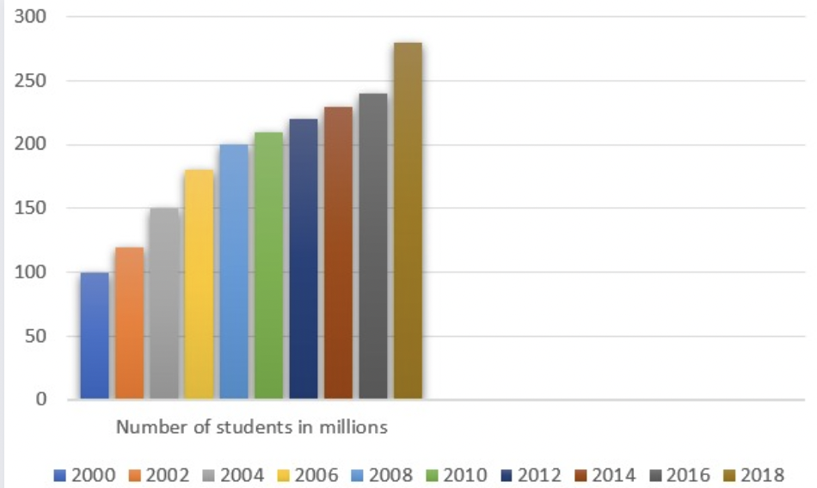*

According to the United Nations Educational, Scientific and Cultural Organization (UNESCO), the number of students enrolled in higher education worldwide increased from 100 million in 2000 to over 220 million in 2014. This growth has been driven by increased demand for higher education in developing countries, particularly in Asia and Africa.

**

According to the latest available statistics, the internationalization of higher education in Kazakhstan has been steadily increasing over the years. Some key statistics include:

As of 2020, there were more than 87,000 international students studying in Kazakhstan, representing over 120 countries. Kazakhstan has established academic partnerships and agreements with over 800 universities in more than 70 countries, including joint research programs and student exchanges. The number of Kazakhstani students studying abroad has also been increasing, with over 11,000 students enrolled in foreign universities in 2019. In 2020, Kazakhstan's top three countries of origin for international students were China, Uzbekistan, and India. There is a statistics report of students that came to Kazakhstan in 2018, 2019, 2020

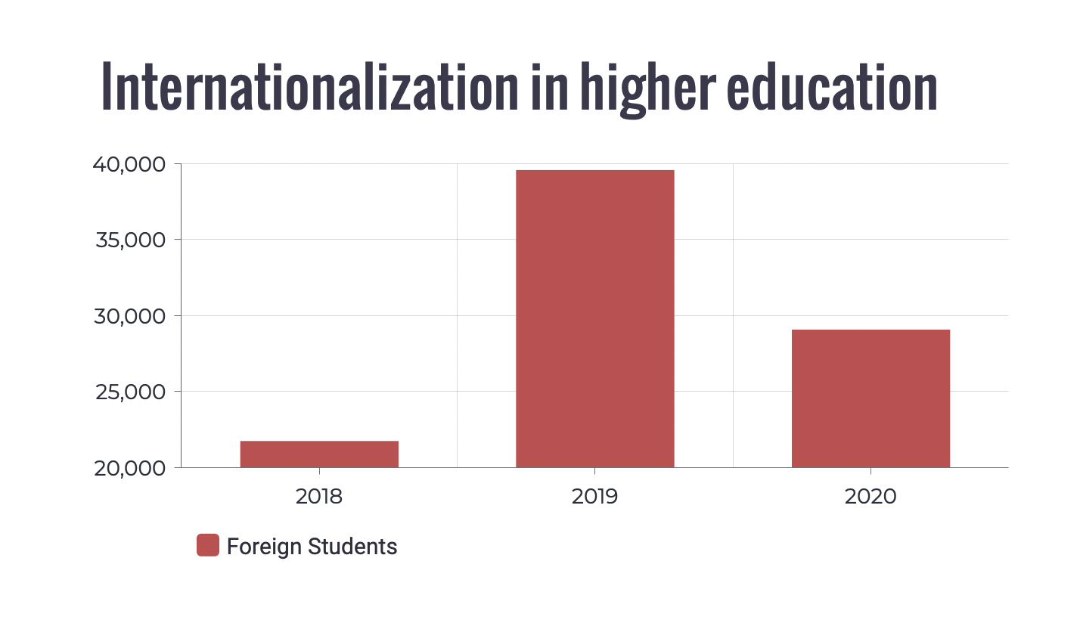

The government of our country has made significant investments in internationalization, with the launch of the Bolashak Scholarship program, which provides funding for Kazakhstani students to study abroad, as well as the establishment of the Nazarbayev University, which aims to become a leading research institution in Central Asia. It is worth noting that these statistics may be subject to change as the situation regarding internationalization in higher education continues to evolve in Kazakhstan.

*2.3 Analysis of the best practices and strategies for managing internationalization*

Here is a comparison of the strengths and weaknesses of internationalization programs at some US universities:

***Harvard University:***

*Strengths:*

Harvard has a long history of international engagement, with an extensive network of global partnerships and research collaborations.

The university has a robust study abroad program, offering students opportunities to study in more than 50 countries.

*Weaknesses:*

Some critics have argued that Harvard's internationalization efforts have been primarily focused on attracting international students and scholars, rather than creating truly diverse and inclusive learning environments.

Despite its global reach, Harvard has been criticized for not doing enough to address global issues such as climate change and inequality.

***University of California, Berkeley:***

*Strengths:*

Berkeley has a strong commitment to global education, with a wide range of international programs and partnerships.

The university has a strong reputation for research and innovation, with many international collaborations.

*Weaknesses:*

Berkeley has been criticized for not doing enough to support underrepresented and marginalized students in its international programs.

The university has faced controversies related to academic freedom and freedom of speech, which may impact its international reputation.

***New York University:***

*Strengths:*

NYU has a highly diverse student body, with students from over 150 countries.

The university has a strong focus on experiential learning and global engagement, with a large number of study abroad programs and global centers.

*Weaknesses:*

NYU has faced criticism for its high tuition costs, which may limit access to its international programs for some students.

The university has been accused of prioritizing its global expansion over its core mission of providing quality education.

***Massachusetts Institute of Technology (MIT):***

*Strengths:*

MIT has a strong focus on innovation and entrepreneurship, with many international collaborations and partnerships.

The university has a robust study abroad program, offering students opportunities to study in over 40 countries.

*Weaknesses:*

Some critics have argued that MIT's internationalization efforts have been too focused on technology and innovation, and not enough on broader societal issues.

The university has been criticized for not doing enough to support underrepresented and marginalized students in its international programs.

It's important to note that these are just a few examples, and that each university's strengths and weaknesses may vary depending on their specific programs and initiatives.

***Best Practices in Managing Internationalization***

Several universities around the world have developed successful internationalization programs, which can serve as examples of best practices in managing internationalization. These best practices include the development of internationalization policies and programs, the cultivation of international partnerships, and the promotion of intercultural competence among students and faculty.

* Development of Internationalization Policies and Programs

Successful internationalization requires a comprehensive strategy and clear policies and programs. Universities should develop internationalization policies and programs that are aligned with their institutional mission and goals. These policies and programs should address issues such as student and faculty exchange programs, joint research projects, and collaborations in curriculum development.

* Cultivation of International Partnerships

International partnerships are essential for successful internationalization. Universities should cultivate partnerships with other institutions around the world, particularly in regions where they have a strategic interest. These partnerships should be based on shared goals and values, and should involve joint projects and collaborations.

* Promotion of Intercultural Competence

Promoting intercultural competence among students and faculty is essential for successful internationalization. Universities should provide training and support to help students and faculty develop intercultural competence, which is the ability to communicate effectively and respectfully across different cultural contexts.

***Strategies for Managing Internationalization***

Based on the literature review and best practices in managing internationalization, several strategies can be proposed for managing internationalization in higher education.

* Develop an Internationalization Strategy

Developing an internationalization strategy is essential for successful internionalization. Universities should develop a comprehensive strategy that is aligned with their institutional mission and goals. This strategy should include clear policies and programs, as well as a plan for cultivating international partnerships.

* Foster International Partnerships

Fostering international partnerships is essential for successful internationalization. Universities should cultivate partnerships with other institutions around the world, particularly in regions where they have a strategic interest. These partnerships should be based on shared goals and values, and should involve joint projects and collaborations.

* Promote Intercultural Competence

Promoting intercultural competence among students and faculty is essential for successful internationalization. Universities should provide training and support to help students and faculty develop intercultural competence, which is the ability to communicate effectively and respectfully across different cultural contexts.

* Allocate Resources and Funding

Implementing internationalization programs can be expensive for universities. Universities should allocate resources and funding to support internationalization, particularly in terms of funding student and faculty exchange programs and establishing international partnerships.

These best practices and strategies can help institutions effectively manage their internationalization efforts and achieve their goals of creating a global and inclusive learning environment. However, it is important to tailor these strategies to the specific needs and context of each institution.

***Conclusion of the 2nd chapter***

So, internationalization has both advantages and disadvantages in higher education. While it can provide students with valuable cross-cultural experiences and promote collaboration and innovation, it can also be costly and present challenges related to language and cultural differences.

*Pros:*

* Cross-cultural competency: Internationalization helps students develop cross-cultural competency by exposing them to different cultures, languages, and traditions. This can help them become more globally aware and better equipped to navigate an increasingly interconnected world.
* Increased collaboration: Internationalization can lead to increased collaboration between universities and researchers from different countries. This can foster the exchange of knowledge and ideas, and contribute to advancements in research and innovation.
* Improved reputation: Universities that have a strong international presence are often seen as more prestigious and reputable, which can attract top talent and funding opportunities.
* Diverse student body: Internationalization can lead to a more diverse student body, which can enrich the learning experience for all students and promote inclusivity.

*Cons:*

* Cost: Internationalization can be expensive, particularly for universities that are just starting to develop their international programs. Costs can include travel expenses, international partnerships, and administrative expenses.
* Language barriers: Language barriers can make it difficult for international students to fully engage in the classroom and for faculty to communicate effectively with students who speak different languages.
* Cultural differences: Cultural differences can sometimes create challenges for international students and faculty, as they adjust to new social norms and customs.
* Brain drain: Internationalization can sometimes lead to a "brain drain," as talented graduates and researchers from developing countries may be lured away by opportunities in developed countries, leading to a loss of talent in their home countries.

**Conclusion**

Effective internationalization management requires a strategic and coordinated approach that involves all stakeholders. Key elements of effective internationalization management include strategic planning, leadership and governance, partnership development, student mobility, faculty development, and cultural competency. By following these recommendations, institutions can successfully navigate the challenges and opportunities associated with internationalization and position themselves as global leaders in higher education.

In conclusion, internationalization is a critical component of higher education in a globalized world. It offers significant benefits to institutions and individuals, including enhanced research excellence, increased student and faculty diversity, and improved reputation. However, it also presents significant challenges that require effective management and coordination. By developing a comprehensive internationalization strategy and implementing effective internationalization management practices, institutions can successfully navigate the challenges and opportunities of internationalization and position themselves as global leaders in higher education.

**LITERATURE**

Altbach, P. G. (2015). The challenges of internationalization in higher education. International Higher Education, (80), 2-3.

De Wit, H. (2019). Internationalization of higher education. In Encyclopedia of international higher education systems and institutions (pp. 1-15). Springer.

Knight, J. (2020). Internationalization in higher education. In The Routledge international handbook of higher education (pp. 409-424). Routledge.

Leask, B. (2015). Internationalizing the curriculum. Routledge.

Marginson, S. (2014). Student self‐formation in international education. Journal of Studies in International Education, 18(1), 6-22.

Mestenhauser, J. A., & Ellingboe, B. J. (1998). Reforming the higher education curriculum: Internationalizing the campus. Phoenix: American Council on Education.

Sánchez, M. A., & Llamas, J. M. (2018). Managing internationalization of higher education: A review of the literature. Journal of International Education in Business, 11(2), 131-149.

Stier, J., & Boccanfuso, C. (2015). Managing internationalization of higher education institutions: A typology of four internationalization models. Journal of Studies in International Education, 19(4), 301-317.

Teferra, D. (2016). Internationalization of higher education in Africa: A critical review and emerging trends. International Journal of African Higher Education, 3(1), 119-132.

Van der Wende, M. (2017). Internationalization in higher education: A turbulent decade. In Key issues in higher education (pp. 33-44). Springer.